SmartCare v0.3 - Domain Model Workbook
Week 6 student resource

Requirement-to-Concept Trace
Requirement | Concept | State/behaviour | Decision
FR-01 | Patient | State: patient_id, name, date_of_birth, phone. | Class
FR-02 | Patient, Clinic | Behaviour: Patient.matches(search_term); Clinic.find_patient(search_term). | No search class
Fr-03 | Patient | Behaviour: update_details(name, phone). | Class
Fr-4 | Practitioner | State: practitioner_id, name, role. | Class
Fr-5 | Appointment | State: appointment_id, patient, practitioner, date_time, status | Class
Fr-6 | Practitioner, Appointment | Behaviour: Practitioner.is_busy(date_time), called by Clinic.book_appointment() before an Appointment is created. | Unsure
Fr-7 | Appointment | Behaviour: validation of every required value at creation. | Rule allocated to appointment
Fr-8, fr-9 | Appointmentstatus | State: one of Booked, Cancelled, Completed. Behaviour: Appointment.cancel(), Appointment.is_active(). | Not a class
Fr-10, fr-11 | Practitioner, Patient | Behaviour: Practitioner.schedule_for(date); Patient.history(). | No class
Fr-12 | Clinic | State: the patient, practitioner and appointment registers. Behaviour: save(), load(). | unsure

CRC Cards
Patient
Responsibilities | Collaborators
Supplies its appointment history, including cancelled | Appointment
Report if it matches a search term, by name or identifier | None
Practitioner
Responsibilities | Collaborators
Report whether there is an active appointment at a given date and time | Appointment
Supplies appointments for a chosen day | Appointment
Appointment
Responsibilities | Collaborators
Refuse to create when a value is missing | None
Know the patient, practitioner, date and time it belongs to | Patient, practitioner

Optional class: Clinic
Responsibilities | Collaborators
Holds the registers of patients, practitioners and appointments | Patient, practitioner and appointment
Find a patient by name or identifier | patient

UML Class Diagram
Insert/draw UML here. Include defensible relationships and multiplicities.
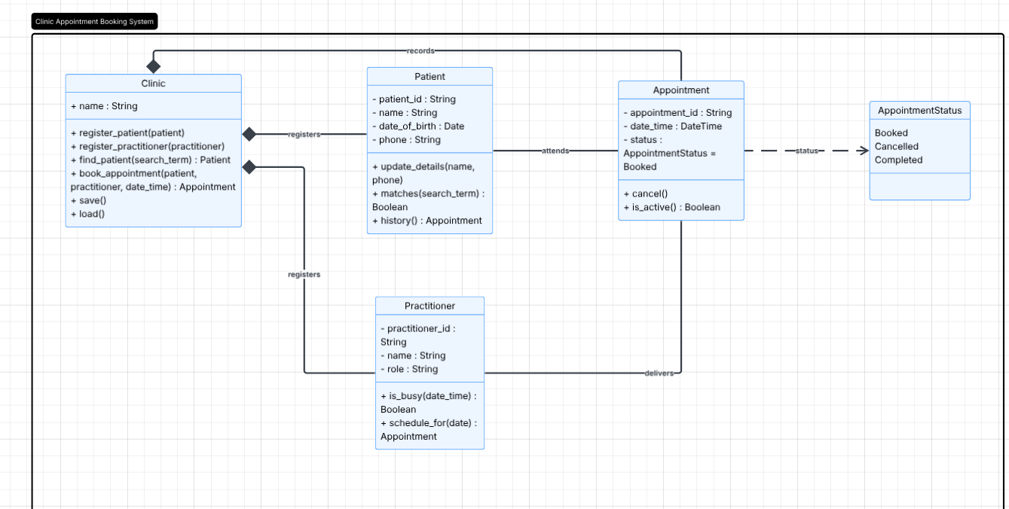

Design Rationale
Explain class selection, responsibility allocation and key relationships.
Following the case study, four classes were selected however clinic can be considered optional. Patient, practitioner and appointment were chosen by seeing it applied against 2 questions: Does it hold state that persists beyond a single operation and does it have behaviour of its own? Overall they pass and on top of this are named in my requirements.
Clinic is added for 2 reasons, FR-06 cant be checked from inside a single appoint because the clas is only visible across a set of appoints and FR-12 needs one object that owns everything. For responsibilities, they are allocated to the object that holds the data needed to answer it. E.g. availability is on practitioner because only that specific prac’s appointments matter, status and cancellation sit on appointment, search mathcning sits on patient while the match is on client.
Lastly the relationships follow pretty much the same evidence. For patient to appointment it’s a binary association, every appointment will be linked with atleast one patient, one patient to zero or more appointments. Its not composition since appointment is not part of patient, its shared with practitioner.

AI Design Review Record
AI suggestion | Evidence | Decision | Reason | Model change
PatientManager | None cited | rejected | state and the rules already belong to Patient and the collection already belongs to Clinic. | None
PractitionerManager | none cited | Rejected | Same as patient | None
AppointmentManager | Partially | Modified | The need is real but three managers are not. | Clinic added as the fourth class
ClinicController | None | Rejected | There is no second boundary to control. | None
Notificationmanager | None | Rejected | Remains provisional | None
ScheduleEngine | none | Rejected | An engine implies allocation or optimisation, which is out of scope. | none

